ASSIGNMENT 2 - OPERATING SYSTEMS

BY SHERYL SUSAN IDICULLA

1)Viewing entry logs

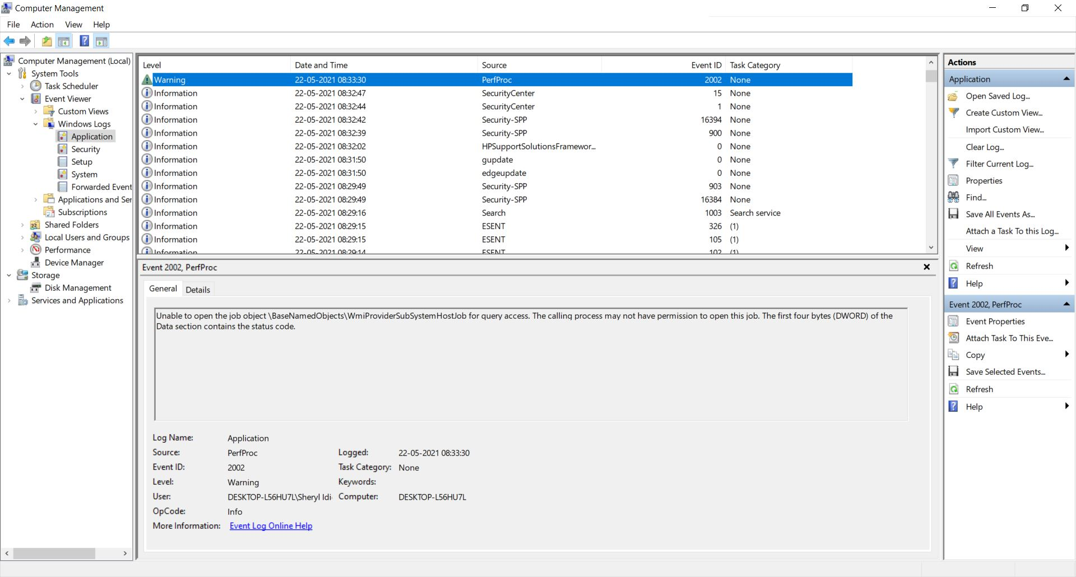

1. Finding file to be deleted

Using Get-Name and Remove-Item commands

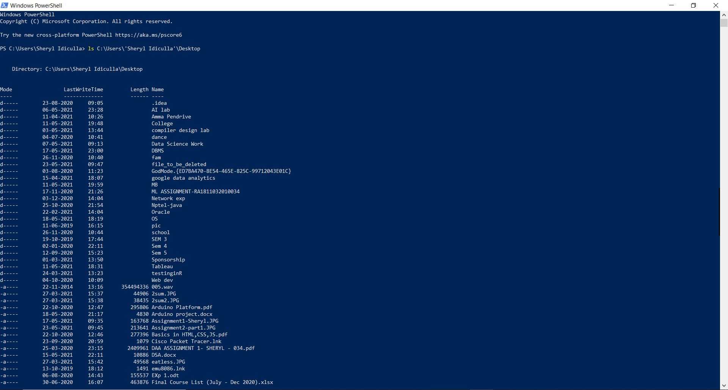

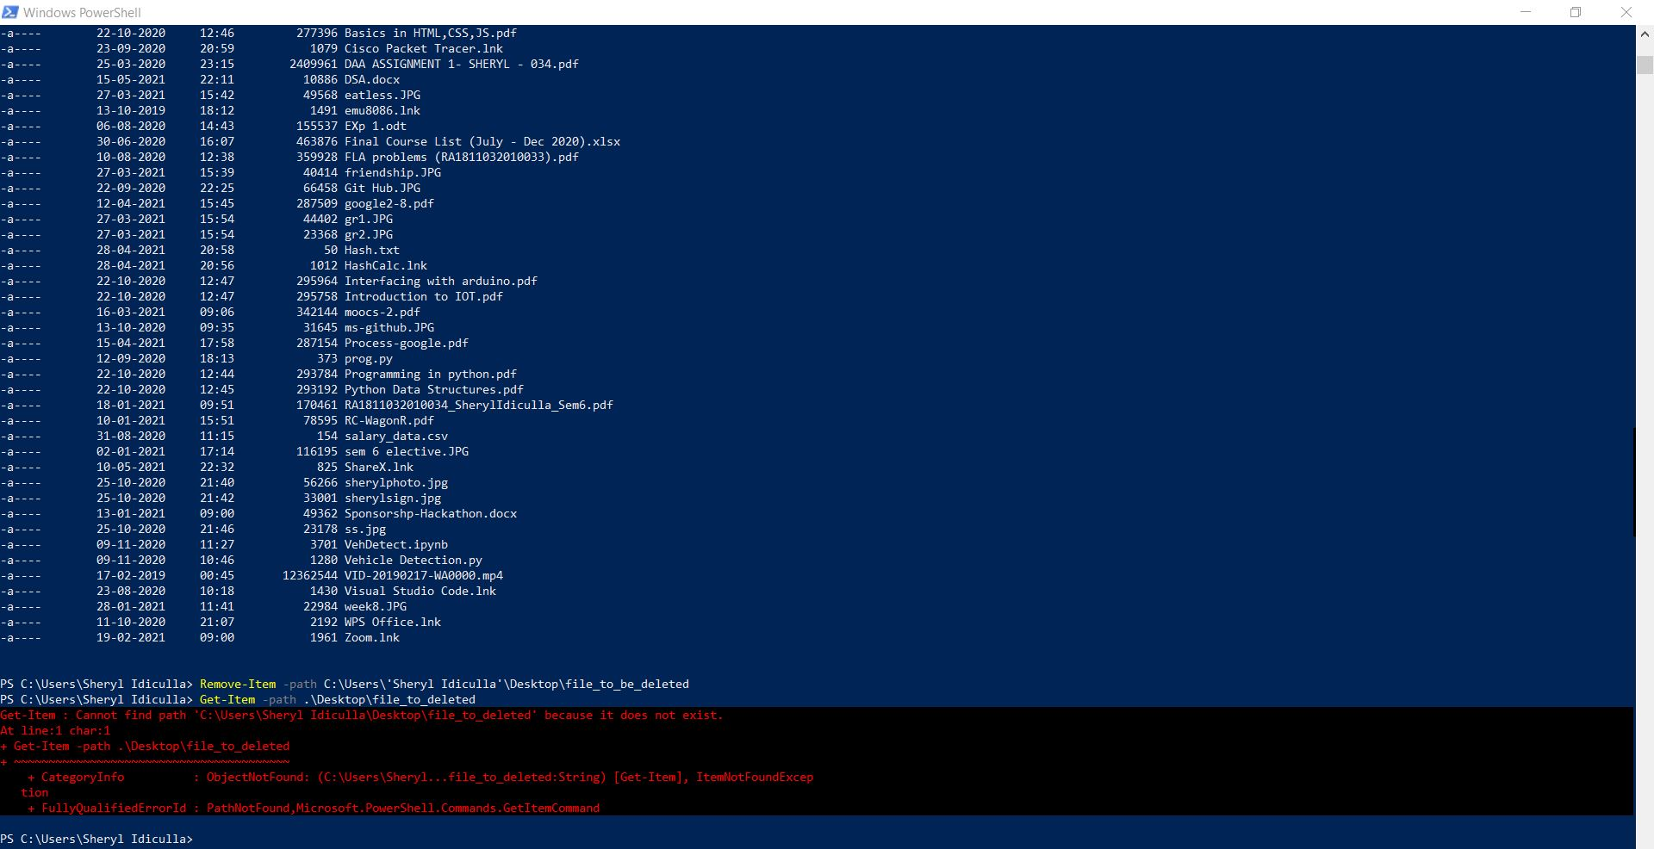

1. Giving File Permissions

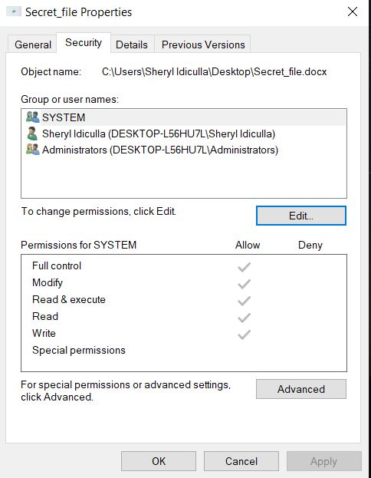

1. Getting process ID and killing process

